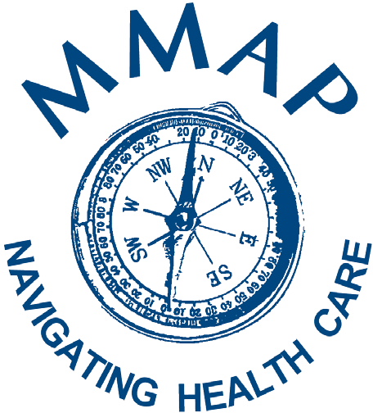

**Now is the time to shop for your Medicare 2022 Prescription Plan...**

**Save money and get the best coverage!**

If you have Medicare, you can choose a new plan during open enrollment. Coverage begins January 1

**Open Enrollment October 15 - December 7**

**It’s worth it to take the time to compare**

# A local MMAP Counselor can:

* Help you compare your current plan with other Medicare drug plan choices
* Help you sign up for a new Medicare drug plan

To find a counselor near you:

**Call 1-800-803-7174**

MMAP is a free service which is funded by grants from the U.S. Department of Health & Human Services – the Administration for Community Living, the Michigan Department of Health and Human Services, and Michigan Aging and Adult Services Agency. MMAP does not receive funding from, nor is it affiliated with, any insurance companies.

 